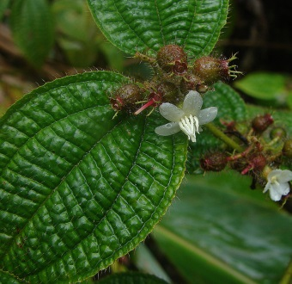
Koster’s curse
Six weed species that have been introduced to Australia are targeted for national eradication or complete removal. One of those weeds is Koster’s curse (Clidemia hirta).
The eradication program maps and monitors the full distribution of these species and coordinates activities to eradicate the species from Australia. The program involves extensive community engagement to:
- identify infested areas

Culbert, D, 2007, Koster’s Curse Flower, http://flickr.com/photos/92252798@N07/10006921655 CC BY 2.0 creativecommons.org/licenses/by/2.0/

- conduct targeted weed surveys for weed control
- identify research components.
Description
Koster’s curse (Clidemia hirta) is a densely branching, long-lived shrub that is commonly 0.5–3 m tall, but may reach as much as 5 m in shaded areas. Its branches and leaves are covered in large, stiff, brown or reddish hairs.
The bristly flowers are small and white or occasionally pinkish and are arranged in small clusters in the leaf forks or at the tips of the branches.
Key points | - Koster's curse is only known to have naturalised at one locality in Australia (Julatten, north Queensland). At the time of its discovery, steps were taken to eradicate it.  - It is naturalised in many tropical countries, being a highly invasive species of both disturbed and undisturbed habitats.  - It can form dense thickets that smother plantations, pastures and native vegetation, much like lantana.  - In Hawaii, Koster’s curse infests more than 40 000 hectares and negatively affects native ecosystems.  - The potential distribution of Koster's curse in Australia includes humid coastal sites in the Northern Territory and much of northeast Queensland.
How it spreads | Berries of Koster’s curse can be dispersed in water, but the most common dispersal method is by birds. A mature shrub can produce thousands of berries, most of which end up being dispersed by birds. It has been noted that in Hawaii Koster’s curse berries may be spread by vehicles, people and pigs (Waterhouse 2003; Land Protection 2005; Gerlach 2006).
Where it grows | Koster’s curse prefers humid tropical climates and invades both disturbed and undisturbed habitats. In such areas in Australia it is a potential weed of pastures, roadsides, woodlands and rainforests (Navie 2004).
Impacts | From knowledge of where this plant has naturalised overseas, there seems no doubt that establishment of Koster’s curse in Australia would be highly undesirable. It can form dense thickets that smother plantations, pastures and native vegetation, much like lantana. It has the potential to cause significant damage to primary production as well as sensitive habitats and native plant communities, especially in the wet tropics (Land Protection 2005).  In Hawaii, it infests more than 40 000 hectares and may be replacing endemic species that formerly predominated, threatening their extinction. The impact of this weed on native species and ecosystems is devastating and the rate at which it spreads throughout the islands is alarming (Gerlach 2006). It is a highly invasive shrub in the montane rainforests and cloud forests of Samoa, Fiji, Wallis and Futuna. In the Pasoh Forest Reserve on the Malaysian Peninsula competition with native species in forest gaps has the potential to alter forest regeneration. Koster’s curse is one of the most problematic invasive species in the Comoros Archipelago, Réunion, Mauritius and the Seychelles (Gerlach 2006).
Origin | Koster's curse is a native of tropical America, extending from southern Mexico to northern Argentina and islands of the Caribbean.
Description adapted from: Weeds in Australia: Clidemia hirta, © Commonwealth of Australia 2013 (Department of the Environment), https://www.environment.gov.au/cgi-bin/biodiversity/invasive/weeds/weeddetails.pl?taxon_id=68475 CC BY 4.0 creativecommons.org/licenses/by/4.0/

